How Do Organisms Reproduce?
Meiosis (Production of Haploid Sex Cells)
Part I. Meiosis

- Recall that chromosomes are composed of DNA and contain the genetic blueprint for an organism. Each species has its own unique set of chromosome, and all individuals in a particular species typically have the same number of chromosomes. Humans have 46 chromosomes. The domestic dog has 78 chromosomes, the domestic cat has 38 chromosomes, and the mouse that it chases has 40 chromosomes!

- Within each individual in a species, every somatic cell contains the same number of chromosomes as every other. Humans (and most other animals) are diploid organisms meaning that each cell contains two complete chromosome sets.

- From where were these two chromosome sets initially inherited?

- Human gametes (sex cells) are haploid cells, meaning that they have only one complete set of chromosomes.

- If human somatic cells have 46 chromosomes, how many chromosomes do human gametes have?

- When fertilization occurs, the haploid sperm cell and haploid egg cell join, producing a fertilized zygote. This "restores" the diploid chromosome number.

- How many chromosomes do fertilized eggs contain? Are fertilized eggs haploid cells or diploid cells?

Modeling Meiosis
- You are going to work through the cellular events involved in meiosis step by step. Your will be working with the chromosomes of a Triffle , a mythical organism. You and your teammates are to complete the following steps, and then repeat the process until you can go through it without using these instructions. The Triffle has a diploid chromosome number of four.

- What will the haploid chromosome number be?

- Setting up the Cell:
  - Lay down the large oval of white paper in the center of your work space. Imagine that this is one sex cell in a Triffle. The boundary of the paper is the cell membrane.

- Setting up the Genome:
  - You are going to create a diploid nucleus containing two pairs of chromosomes. First, divide each of your four balls of colored clay in half.
  - Take one-half of each ball and roll it between your hands to form an elongated, snakelike piece. You will have four chromosome models. Make the green and yellow chromosomes about 4 inches long and the red and blue pair about 6 inches long. We will refer to the yellow/green pair as PAIR 1 and the blue/red pair as PAIR 2.
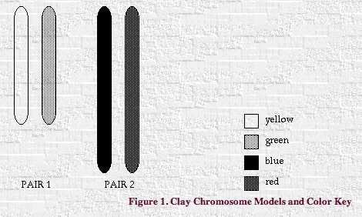
  - Remember that a chromosome is tightly coiled strand of DNA. Within each chromosome there are many, many genes. The chromosomes within each pair are said to be homologous­­meaning similar but not necessarily identical. Homologous chromosomes contain the same genes but not necessarily the same alleles. For instance, two homologous chromosomes might contain the gene which codes for eye color, but the allele form might be different--like blue eye allele on one chromosome and brown eye allele on the other.
  - We are going to examine four Mendelian traits in the Triffle, specified by four genes. Remember that genes are segments of chromosomes which code for proteins that can result in the expression of detectable traits (phenotypes). Table I describes some imaginary traits of our mythical creature and their location on each chromosomes.

Table I
 | Genes on PAIR 1
 | Fur Color | Fur Type
Green Chromosome | G (green fur) | c (straight fur)
Yellow Chromosome | g (yellow fur) | C (curly fur)
 | Genes on PAIR 2
 | Eye Color | Eyelash length
Blue Chromosome | B (blue eyes) | L (long eyelashes)
Red Chromosome | g (red eyes) | l (short eyelashes)
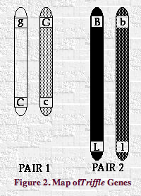
  - Note that we are looking at only two genes (two pairs of alleles) on each chromosome, while ignoring hundreds of other genes. Also, note that the triffle we are studying is completely heterozygous for all four genes examined. This does not always have to be the case.
  - Label the location of each gene by carving into the clay with a sharp object.
- Interphase
  - During interphase, each chromosome is replicated by DNA replication. Simulate replication by creating a matching chromosome (same shape and color) using the remaining bits of clay for each of the four chromosomes in your genome. Label each chromatid with genes so they are exact copies.
  - Connect sister chromatids together at the centromere by pinching them together.
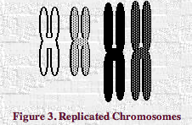
- How many chromatids are present in the nucleus after DNA replication? How many chromosomes?
- Prophase 1
  - Pair up each newly replicated chromosome with its homologous chromosome. This pairing will produce two tetrads containing 4 sister chromatids each. There should be 8 chromatids in all.
  - Now that homologous chromosomes are near each other, crossing-over can occur. In each tetrad, trade one allele between two non-sister (non-identical) chromatids by first overlapping chromosome arms to form a cross-over.
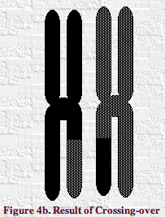
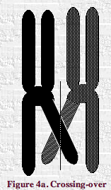
  - Break the clay vertically to separate the chromosomes again, and join the exchanged parts to their new chromosome.

- Metaphase 1
  - Imagine that the nuclear membrane has now broken down in your imaginary Triffle cell.
  - Line the two tetrads end to end across the center of the cell.
  - Attach a piece of black yarn (spindle fiber) stretching from the centromere of each chromosome to the end of the cell nearest to it.
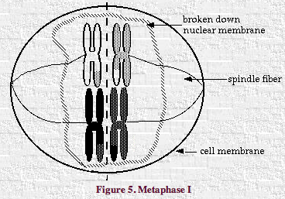
- Was there a reason why the red chromosome ended up on the same side as the green chromosome, or was it random? Why or why not?
- Anaphase 1
  - Separate each tetrad and use the spindle fibers to move the homologous chromosomes to opposite poles of the cell.
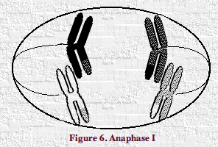
- Teleophase 1
  - Cytokinesis (cell division) occurs to form two daughter cells. These daughter cells are neither haploid or diploid, but rather exist in some intermediate stage.
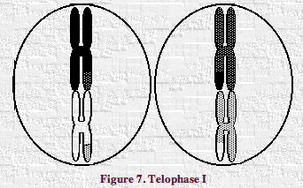
- Are the two daughter cells identical (in genetic makeup)? Why or why not?
- Prophase 2 and Metaphase 2
  - Line up the chromosomes in each cell end to end along the center line. Attach spindle fibers to the centromeres.
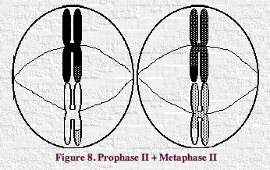
- Anaphase 2
  - Separate the two sister chromatids and use the spindle fibers to move them to opposite poles.
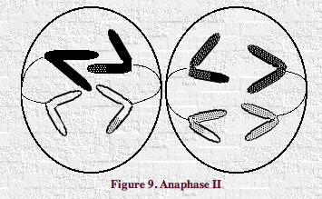
- In anaphase II, what must happen to the centromere region?
- Teleophase 2
  - Cytokinesis occurs again, producing a total of four daughter cells.
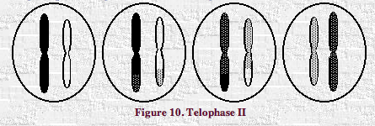
  - Are these cells haploid?
  - Note that each cell has a different genotype (combination of alleles). As a result of gene swapping, each daughter cell contains one or more chromosomes that is different from both those in the parent cell and those in other daughter cells.
- Draw each resulting daughter. Write the genotype beneath each of the resulting daughter cells in your diagrams.
- Cleaning up: Please separate the clay back into four distinct balls so that it can be used in Part II.

Part II. Eggs and Sperm

- In human sex cells, nuclear division occurs in exactly the same way in males and females. By undergoing meiotic cell division, a diploid parent cell will give rise to four haploid daughter cells. However, the process of cytokinesis differs between male and female cells. Recall that cytokinesis occurs on two separate occassions in meiosis, during Telophase I and II.

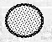
Females
- Select one color of clay from Part I and roll it into a ball of about 1 inch in diameter. Imagine that instead of genetic material (DNA), it is now an entire cell! As a parent sex cell in a female, it is full of nutrients to nourish a developing embryo.
- Pretend that inside the cell:
- chromosome replication occurs,
- the chromosomes condense,
- each replicated chromosome pairs with its partner to form a tetrad,
- the homologous chromosomes swap genes,
- the tetrads line up in the center of the cell,
- and the first nuclear division occurs.
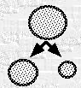
Now its time for the cell undergo the first cytokinesis that takes place in Telophase I.
- Unequally divide the female cell into one small cell and one large one.
- Pretend that
- the chromatid pairs now line up in the center of each cell
- and the two chromatids in each pair separate.
Now, in Telophase II, each cell divides again.
- The small cell divides in half while the large cell divides unequally.
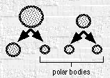
- This unequal division produces three non-functional polar bodies and one functional egg from each female parent cell. The result of this "lopsided" division is that the unfertilized egg inherits nearly all its internal organelles and cytoplasm from the female.

Males
- Choose another color of clay to represent your male parent sex cells. Perform two successive cell divisions starting with the male parent cell. The cells divide in half equally in each division as meiosis proceeds.
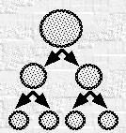

- Each of the four daughter (son?) cells then differentiates, becoming smaller and growing a long flagellum (tail).
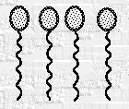
- This produces four viable sperm from each male parent cell. At first, the sperm swim in circles.
- Gradually, they begin to swim in a straight lines.
- Another interesting difference between the sexes is that a woman is born with all the eggs she'll ever have already present in her ovaries. One egg typically matures each month after puberty. In contrast, the male keeps producing new sperm "on demand."
- Based on what you know of the function of the male gamete, do you think it would be advantageous for a sperm cell to be small or large and full of nutrients, like an egg cell? Why?

Fertilization
- Egg cells have a jellylike coating which provides them with protection from their environment. When the whipping tail of a sperm cell propels it to the outside jelly coating of the egg cell, the sperm secretes special enzymes (proteins) which allow it to penetrate the jelly to reach the membrane of the egg cell. The egg cell "recognizes" the sperm cell and engulfs it.

- The sperm cell then travels inside of the egg cell and the haploid nucleus of the sperm fuses with the haploid nucleus of the egg, forming a diploid nucleus. Fertilization is complete!

- Why must gametes be haploid? What might happen if gametes were produced by mitosis and were diploid?

How Do Organisms Reproduce?
Meiosis (Production of Haploid Sex Cells)
Exercises 1 and 2 will take approximately 2 1/2 hours.
- How do parents' genes get passed to their offspring?
- What's the difference between mitosis and meiosis?
- Normal humans carry 46 chromosomes in each cell (2 copies of 23 chromosomes). Why do we have two copies of each of the genes in our genome?
- Can we pick out which genes we want our children to inherit?
For students working in pairs, per pair:
4 one-inch diameter balls of modelling clay of four different colors: red, blue, yellow and green
1 large oval and 4 smaller ovals of white paper
1 pair of scissors
1 2.5-ft. length thick brown yarn
4 1-ft. lengths thick brown yarn
1 1-ft. white string
Once you have completed this lesson you should be able to:
1. Differentiate between haploid cells and diploid cells, the processes of mitosis and meiosis, the characteristics of somatic cells and sex cells.
2. Define gamete, tetrad, chromatid, homologous chromosomes, cytokinesis, polar bodies.
3. Explain how crossing-over in tetrads accounts for genetic variation in a species.
4. Describe the steps involved in meiosis and the significance of each step.
5. Describe how haploid sex cells are generated in parents and how fertilization occurs to produce diploid offspring.
6. Explain the processes of cytokinesis in sperm cells and egg cells and the significance of each.
In this lab we will investigate the cellular basis of variation in organisms by exploring the processes involved in sexual reproduction.
This lab has two parts, Meiosis and Eggs and Sperm. First we will examine how sex cells, or gametes, are generated in males and females. A specialized process, meiotic cell division, produces the gametes, (sperm and egg in humans and other animals, pollen and egg in plants). Meiotic cell divisions occur in specialized cells in the reproductive structures of plants and animals, and other sexually reproducing organisms.
In the second part of the lab, we will explore the phenomenon of cytokinesis and how sperm cells "hedge their bets" while some egg cells end up getting an unequal distribution of the goods.
http://naturalsciences.sdsu.edu/classes/lab2.5/lab2.5.html

